**Multivariate Analysis of Student Habits and Academic Performance**

**Course**: STA4053 - Multivariate Methods II  
**Name**: D.R.K.Dhanushka  
**Reg. Number:** S/19/809

**1. Introduction**

This study investigates how students' daily habits and lifestyle choices affect their academic performance. With the increasing influence of technology, mental health, and socio-environmental factors, identifying key patterns among students is essential. The primary objective is to use multivariate statistical techniques to uncover latent structures and relationships within a comprehensive dataset of 1000 students, ultimately guiding educational strategies and interventions.

**2. Methodology**

**2.1 Dataset Description**

The dataset comprises 1000 student records, each with 16 variables:

* **Continuous Variables:** Age, Study Hours per Day, Social Media Hours, Netflix Hours, Attendance Percentage, Sleep Hours, Exercise Frequency, Mental Health Rating, Exam Score
* **Categorical Variables:** Gender, Part-time Job, Diet Quality, Parental Education Level, Internet Quality, Extracurricular Participation

**2.2 Preprocessing Steps**

* Removed non-analytical ID field (student_id)
* Dropped records with missing values to ensure complete cases for analysis
* Plotted histograms of all numerical variables to assess distribution shapes and detect skewness
* Applied log transformations to variables with high skewness to normalize distributions
* Plotted boxplots of numerical features to identify potential outliers
* Removed outliers using the IQR method to clean the data
* Plotted a correlation heatmap to identify linear relationships and multicollinearity among continuous variables
* Converted categorical variables to dummy/indicator variables for analysis
* Standardized continuous variables for PCA and clustering

**Note :** Although log transformations were applied to reduce skewness in highly skewed variables, some remained moderately skewed. Given the robustness of multivariate techniques to such deviations, analysis proceeded with standardized data.

**2.3 Multivariate Techniques Applied**

* **Principal Component Analysis (PCA):** To reduce dimensionality and identify key underlying components.
* **Cluster Analysis (K-Means):** To segment students into behavioral or performance-based groups.
* **Discriminant Analysis (LDA):** To predict exam performance based on lifestyle indicators.
* **MANOVA:** To analyze how categorical factors influence academic and mental health outcomes.

**3. Results and Discussion**

**3.1 Principal Component Analysis (PCA)**

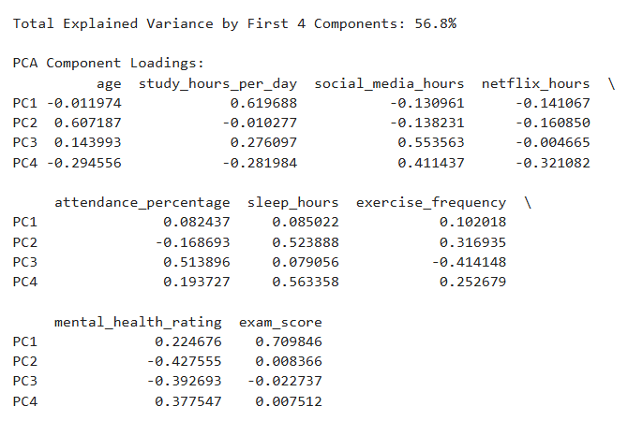

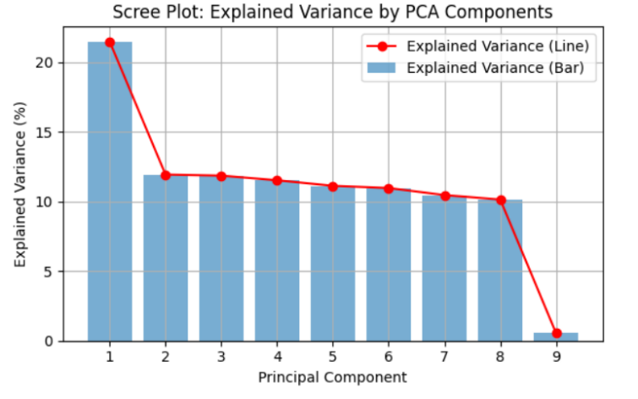

* PCA, with the first four components, explains approximately 56.8% of the total variance.
* While this captures a meaningful portion of the data’s variability, it falls short of the typical 70–80% threshold expected for dimensionality reduction in multivariate analysis.
* As such, the interpretation of the components should be approached with caution, and additional components may be explored in future analyses if higher cumulative variance is needed.

**Interpretation of Principal Components:** The names assigned to each component are based on the strongest variable loadings observed in the PCA loadings matrix. These names are descriptive summaries intended to reflect the shared thematic meaning of the variables contributing most to each component.

* **PC1 (Academic Commitment and Performance):** High positive loadings on study_hours_per_day and exam_score suggest that this component represents students who dedicate time to studying and perform well academically.
* **PC2 (Lifestyle and Physical Wellness):** Strong contributions from sleep_hours and exercise_frequency, and a negative relationship with mental_health_rating, reflect a lifestyle dimension where rest and activity levels are central.
* **PC3 (Engagement and Digital Distraction):** Driven by high social_media_hours and positive attendance_percentage, this component may reflect the tension between classroom involvement and digital distractions.
* **PC4 (Routine Balance and Wellness):** Moderate loadings from sleep_hours, mental_health_rating, and social_media_hours indicate a subtler axis that reflects students’ overall routine balance and psychological well-being.

Despite the moderate explained variance, these components still help simplify complex student behaviors into understandable dimensions that can support clustering and classification tasks. That can be further used in clustering and predictive modeling.

**3.2 Cluster Analysis**

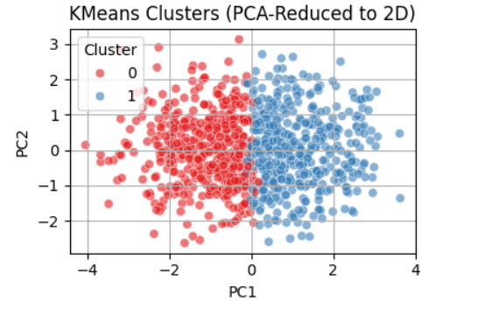

* To identify natural groupings among students based on their standardized behavior and performance data, K-Means clustering was applied.
* The optimal number of clusters was determined to be **2**, based on the silhouette score which measures how well each data point fits within its assigned cluster.
* Visualization of the clusters was achieved by reducing the data to two principal components using PCA, making it easier to interpret the distribution and separation of clusters.

**Cluster Interpretations:** To meaningfully understand each cluster, we computed the average of important behavioral and academic variables per group. Because variables were standardized, the values are in terms of standard deviations (SD) from the mean. The summary statistics helped characterize the clusters based on actual student attributes.

|  |  |  |  |  |  |  |  |
| --- | --- | --- | --- | --- | --- | --- | --- |
| Cluster | Study Hours | Social media | Netflix | Attendance | Sleep | Mental Health | Exam Score |
| 0 | -0.65 | 0.17 | 0.17 | -0.09 | -0.17 | -0.33 | -0.81 |
| 1 | 0.64 | -0.16 | -0.16 | 0.09 | 0.17 | 0.32 | 0.79 |

* **Cluster 0:** These students tend to study less, spend more time on social media and Netflix, sleep less, and report lower mental health and academic scores. They represent the **lower-performing group**.
* **Cluster 1:** This group demonstrates stronger academic behaviors, with more study time, better sleep and mental health, and higher exam scores. They represent the **higher-performing students**.

This analysis highlights behavioral patterns that align with academic outcomes and can inform targeted interventions or student support strategies. Low performers with high social media/Netflix time and poor sleep.

**3.3 Discriminant Analysis**

Linear Discriminant Analysis (LDA) was used to predict academic performance groups (Low, Medium, High) based on students' lifestyle and background features.

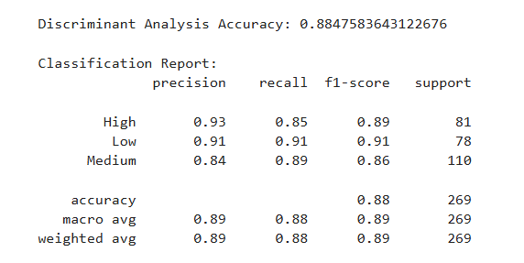

* Categorized exam_score into High (>=80), Medium (60–79), Low (<60)
* Accuracy: 88.5% on the test set
* The model shows strong predictive performance, with all three categories of performance (High, Medium, Low) being classified with good balance between precision and recall.
* Classification Performance:
  + **High Performers:** Precision = 0.93, Recall = 0.85, F1-score = 0.89 — indicating most high scorers were correctly identified
  + **Low Performers:** Precision = 0.91, Recall = 0.91, F1-score = 0.91 — the model effectively captured struggling students
  + **Medium Performers:** Precision = 0.84, Recall = 0.89, F1-score = 0.86 — slightly lower precision but strong recall for middle-range students

Key Predictors Identified from LDA Loadings:

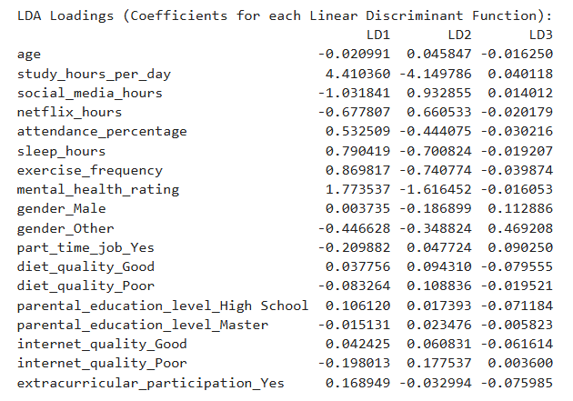

* The most influential predictors in separating the groups were:
  + study_hours_per_day (strongly positive in LD1)
  + mental_health_rating and exercise_frequency
  + sleep_hours, social_media_hours, and attendance_percentage
* These were determined based on their high absolute coefficient values in the first two discriminant functions (LD1 and LD2).

**These findings align with expected patterns:** Academically successful students tend to spend more time studying, maintain healthier routines, and experience better mental health.

**Interpretation:** The model's accuracy of 88.5% demonstrated its excellent ability to distinguish between performance levels. LD1 captured separation between high and low performers based largely on study time, mental health, and wellness factors, while LD2 further refined distinctions using similar lifestyle indicators.

These findings confirm that consistent study habits, mental well-being, and balanced lifestyle factors are reliable student performance indicators and can help guide early academic support.

**3.4 MANOVA**

MANOVA (Multivariate Analysis of Variance) was used to assess how several categorical variables influence both exam score and mental health rating.

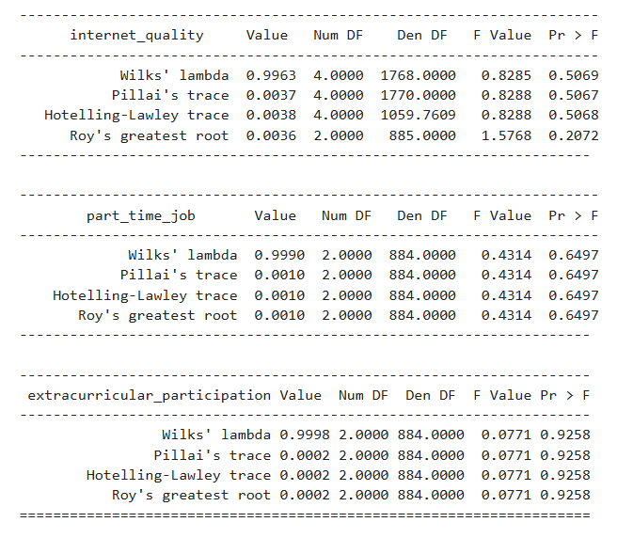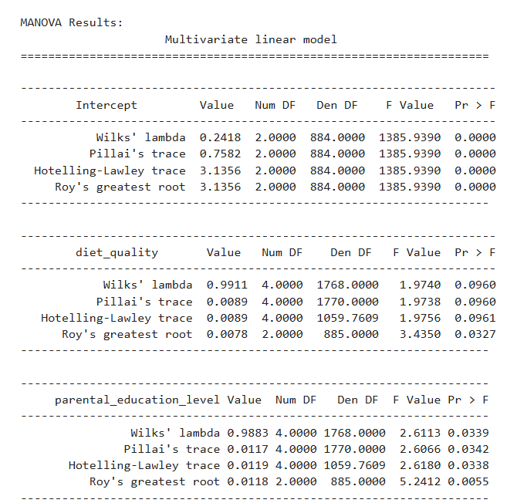

* **Significant Predictor:**
  + Parental Education Level showed a statistically significant multivariate effect (Wilks' λ = 0.9883, F = 2.61, p = 0.034), suggesting students with higher parental education levels tend to perform better academically and report better mental health.
* **Marginal Predictor:**
  + Diet Quality showed a marginal multivariate effect (Wilks' λ = 0.9911, F = 1.97, p = 0.096). Although not statistically significant at the 0.05 level, it may still play a minor role in student outcomes and could be explored further.
* **Non-significant Predictors:**
  + Internet Quality, Part-Time Job, and Extracurricular Participation did not show statistically significant multivariate effects (p > 0.05).

These results highlight the role of family educational background as a contributing factor to student success, while other lifestyle or contextual variables appear to have limited multivariate influence in this dataset.

**4. Conclusion and Recommendation**

This study demonstrates how multivariate techniques can uncover relationships between student behaviors and academic performance. PCA identified meaningful, though moderately explanatory, behavioral dimensions. Clustering highlighted distinct performance-based student groups, and LDA achieved high accuracy in predicting performance levels. MANOVA revealed that among the contextual factors analyzed, only parental education level had a statistically significant effect on both academic and mental health outcomes.

**Key Takeaways:**

* Academic engagement (study hours, attendance) and personal wellness (sleep, mental health) are major differentiators between high and low performers.
* PCA helped reduce dimensionality, though it captured slightly less variance than expected, suggesting potential for additional feature inclusion or alternative methods.
* Discriminant Analysis provided robust performance for academic group classification.
* MANOVA confirmed the relevance of parental education level as a contextual factor, while internet quality, part-time jobs, and extracurriculars had limited statistical influence.

**Limitations:**

* Self-reported data may include bias or inaccuracies.
* Temporal changes (e.g., exam season effects) were not accounted for.

**Recommendations:**

* Encourage structured study routines and consistent attendance.
* Integrate mental health support and sleep hygiene education into academic programs.
* Use cluster insights to design targeted interventions for struggling students.
* Consider additional behavioral or psychological factors in future data collection to improve model variance explanation.

**5. References**

* Hair, J. F., Black, W. C., Babin, B. J., & Anderson, R. E. (2019). *Multivariate Data Analysis* (8th ed.). Cengage Learning.
* Tabachnick, B. G., & Fidell, L. S. (2013). *Using Multivariate Statistics* (6th ed.). Pearson.

**6. Appendices**

* **Dataset :** <https://www.kaggle.com/datasets/jayaantanaath/student-habits-vs-academic-performance>
* **Python Code :**

**Import Important Libraries**

**Exploratory Data Analysis**

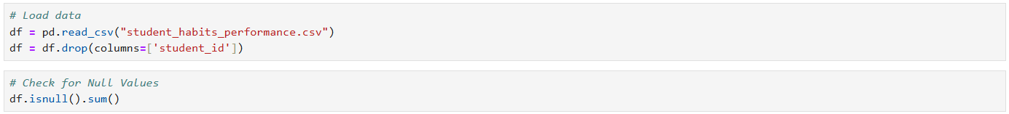

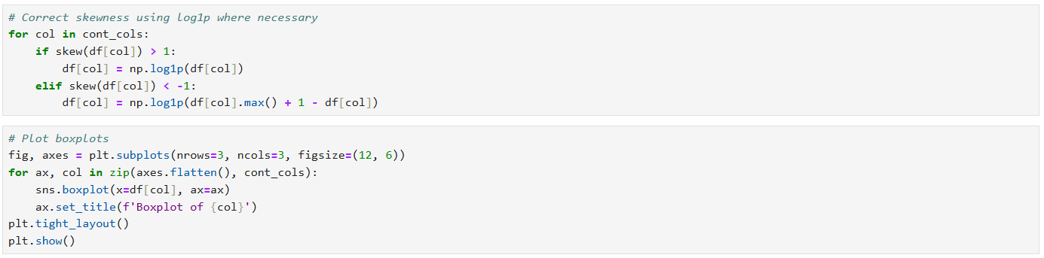

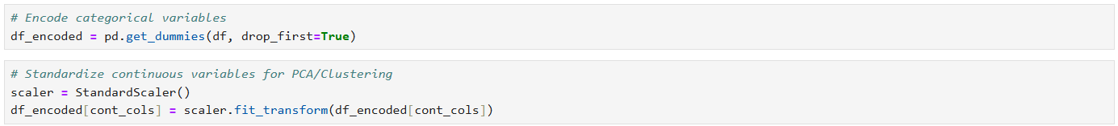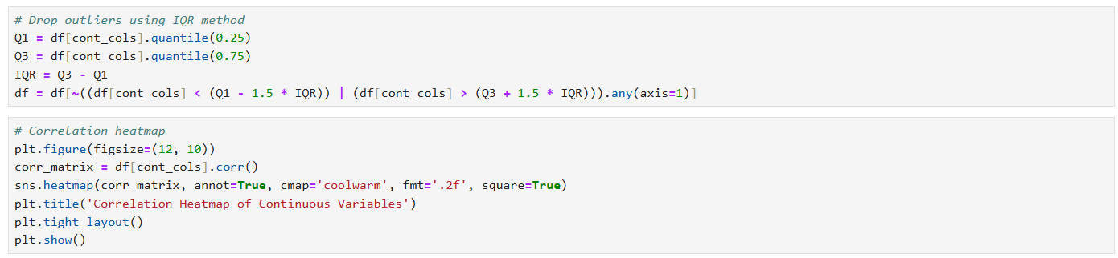

**Principal Component Analysis (PCA)**

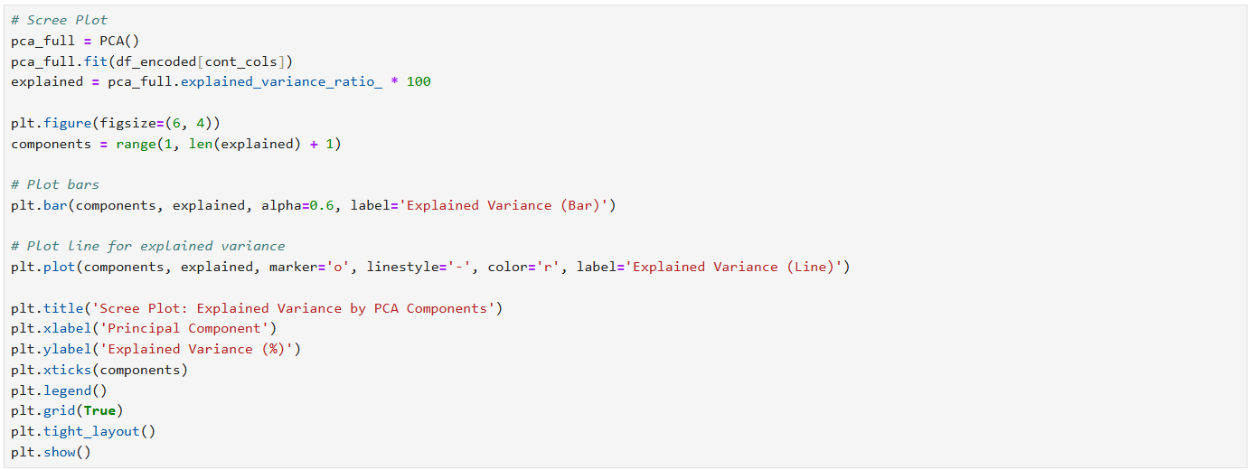

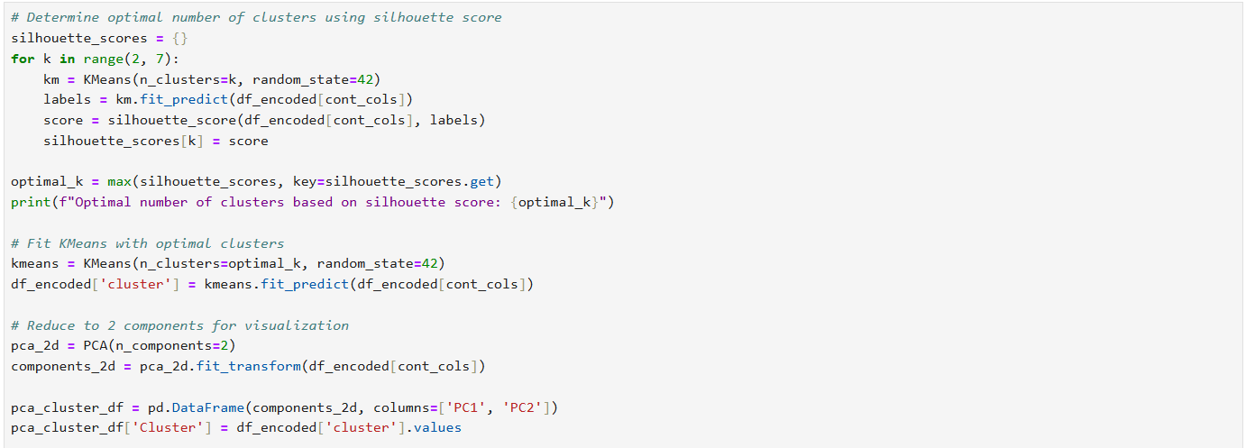**Cluster Analysis (K-Means)**

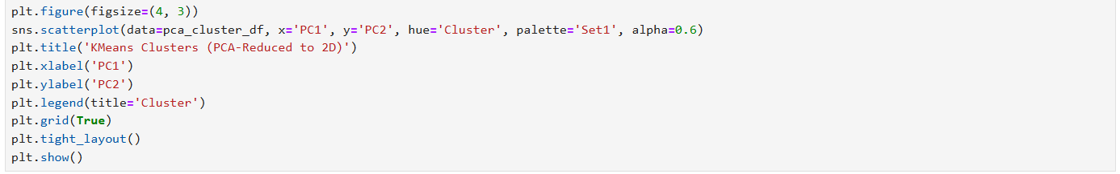

**Discriminant Analysis (LDA)**

**MANOVA**

